Parrot GPS Trackers
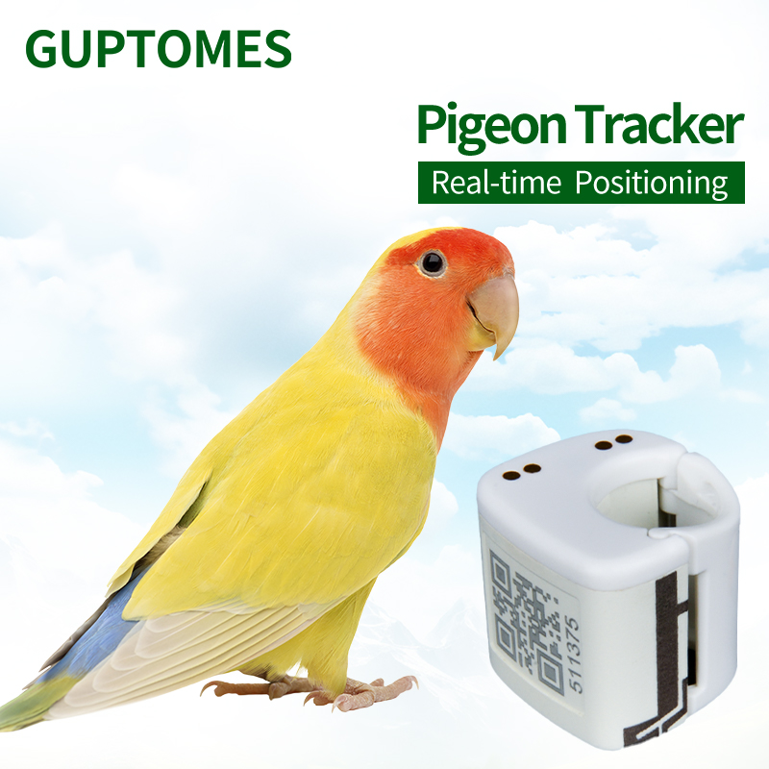
Price：$54.3
Product model：V11
Product parameter：
Positioning Mode | GPS + LBS
Network | 2G
Charging Method | Charging dock + Type-C
Positioning Accuracy | 5–15 meters
Waterproof Rating | Daily waterproof
Battery Life | 24–48 hours (tracking every 12 hours)
Battery Capacity | 80mAh
Dimensions | 20 × 20 × 20 mm
Weight | 5.4g
Product feature：
• Ultra-Lightweight & Compact: Weighing only 5.4g and measuring 20x20x20mm, this device is specifically designed to be easily worn by a small bird like a parrot without hindering its movement or flight.
• Dual Positioning: Uses a combination of GPS and LBS for accurate and reliable location tracking.
• Dual Charging Method: Can be charged using either a charging dock or a Type-C cable, offering flexible and convenient charging options.
• Daily Waterproof: The tracker has a daily waterproof rating, protecting it from moisture and light rain.
• Long Standby: The 80mAh battery provides a battery life of 24-48 hours, with tracking available every 12 hours.
• Durable Design: The device is built to be robust and certified for waterproof use.
Product function：
• Precise Positioning: Provides accurate location data for the parrot's whereabouts.
• Historical Trajectory: Allows users to view the parrot's past flight paths.
• Geo-Fence: Users can set up virtual boundaries and receive an alert if the parrot flies outside a specific area.
• Built-in Map: The flight data is displayed on a built-in map for easy visualization.
• Flight Path Tracking: Specifically designed to log and display the parrot's exact flight path.

